**ASSIGNMENT-8.4**

**PROBLEM STATEMENT:**

Parsing XML files using pig

Convert the XML file into CSV and save the CSV output in a file using pig.

**STEPS REQUIRED** :

Firstly load the required xml file as x as shown in screenshot below :

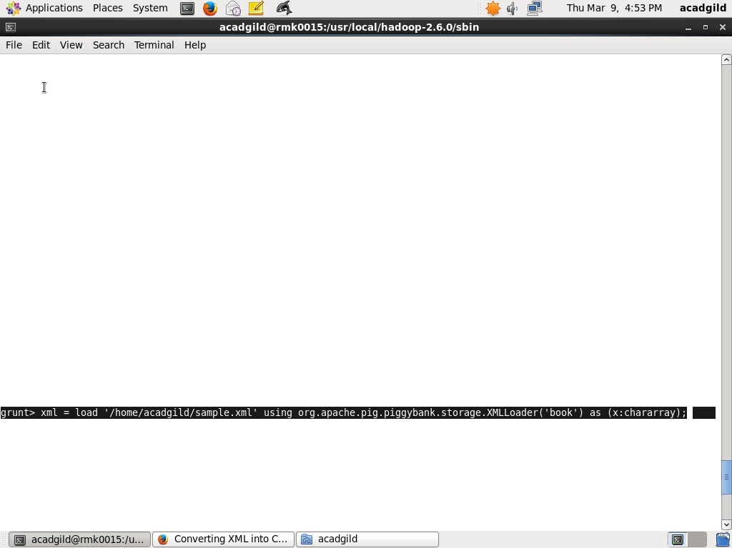

**ADDITIONAL STEPS REQUIRED :**

1. Firstly make the whole extended XML data into a single line data.
2. Removal of the tag lines is done by extracting only its data
3. Flattening of the required data is performed
4. Storing into a separate file seperately

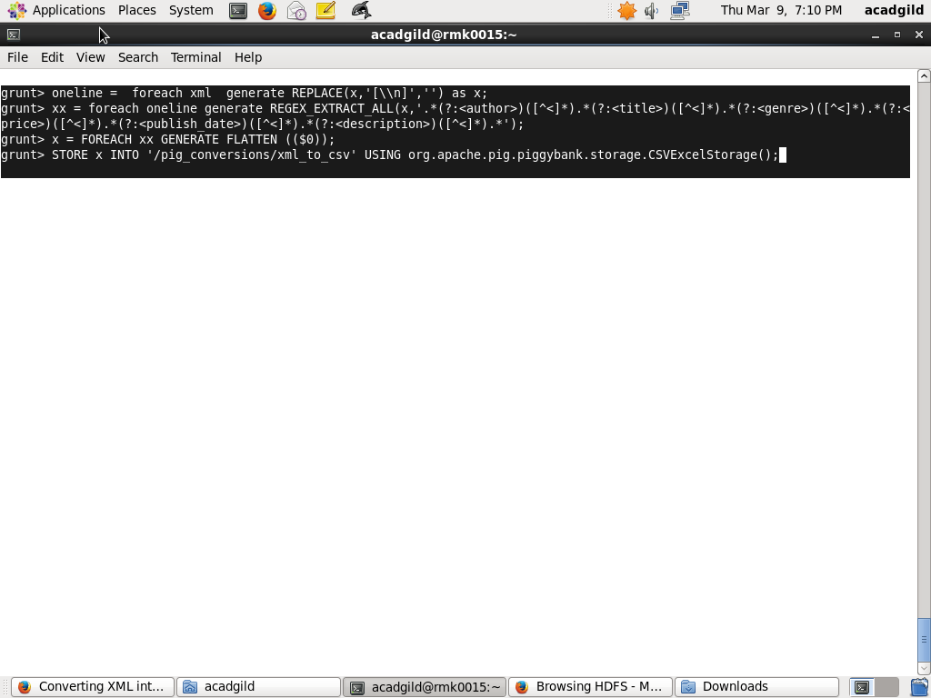

**OUTPUT FILE IN CSV** **FORM** :

